|  |
| --- |
|  |
| The Documentation |
| [Type the document subtitle] |
|  |
| **[Your Name]** |
| **[Pick the date]** |

[Type the abstract of the document here. The abstract is typically a short summary of the contents of the document. Type the abstract of the document here. The abstract is typically a short summary of the contents of the document.]

Table of Contents

[To update the table of contents, right click the message below and select Update Field (F9 on PC, ⌥⌘U on Mac).]

**No table of contents entries found.**

1. Pages
   1. Page Tree

Public  
 Landing Page  
 Product Details (From Landing page))  
 Categorized Products  
 Search Results (Landing Page)  
 Product Details (From Search Results))  
 Sign Up (Buyer)  
 (Buyer) Sign Up Confirmation Page  
 (Buyer) Successful registration  
 Sign Up (Seller)  
 (Seller) Sign Up Confirmation Page  
 (Seller) Successful registration  
 Log In  
Private  
 Buyer  
 BuyerHomepage  
 Product Details (From Homepage)  
 Categorized Products  
 Buyer Profile  
 Search Results  
 Product Details (From Search Results))  
 Seller  
 SellerHomepage  
 Product Details (From Homepage) (1)  
 Seller Profile

* 1. Landing Page
     1. User Interface

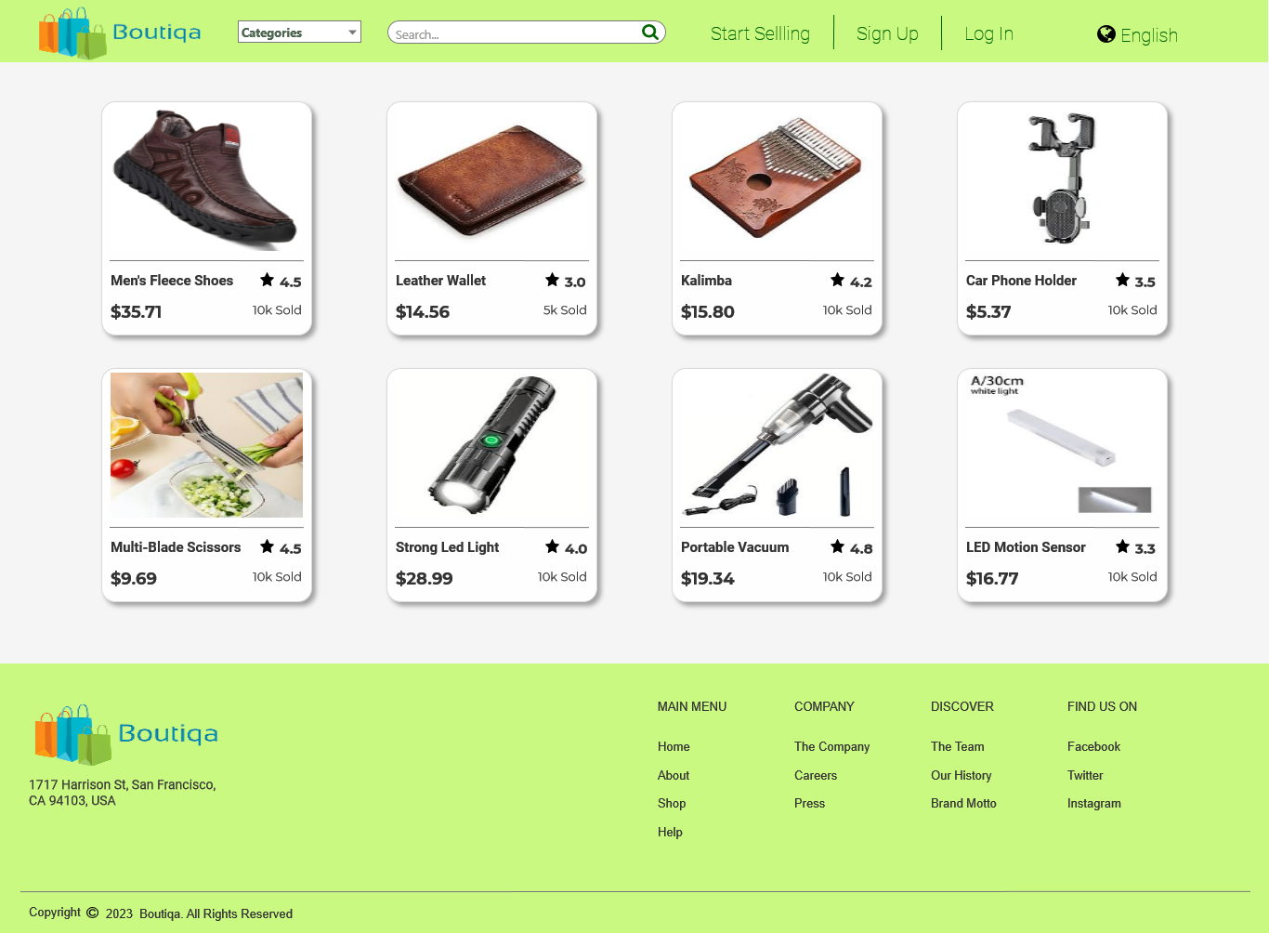

* + 1. Products
       1. User Interface

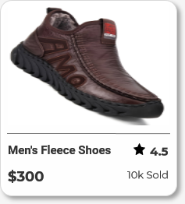

* 1. Product Details (From Landing page))

Page Loaded:  
 Set text on ProductName equal to value of DetailsProductName  
 Set text on ProductPrice equal to value of DetailsProductPrice  
 Set text on ProductRatings equal to value of DetailsProductRatings  
 Set text on ProductSoldPlaceholder equal to value of DetailsProductSold  
 Set text on ProductDetails equal to value of DetailsProductDescription  
 Set text on ProductNameBreadcrum equal to value of DetailsProductName  
 Set (Dynamic Panel) to to [[DetailsProductImage]]

* + 1. User Interface

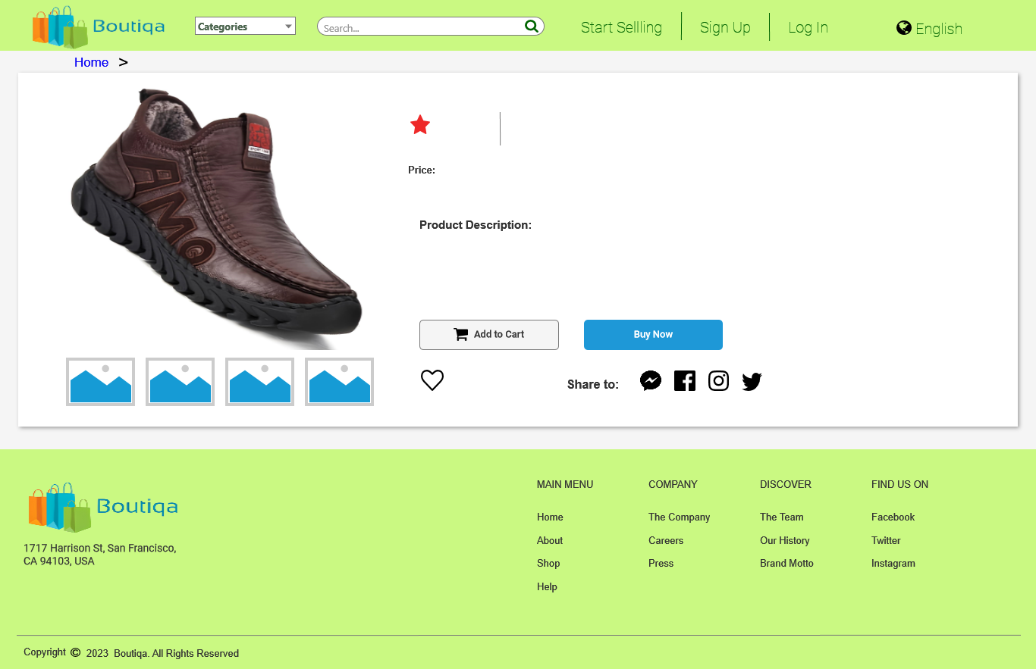

* + 1. Unnamed
       1. State 1
       2. User Interface



* + - 1. State 2
      2. User Interface

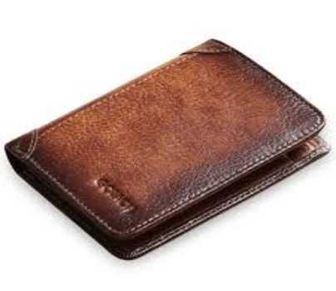

* + - 1. State 3
      2. User Interface

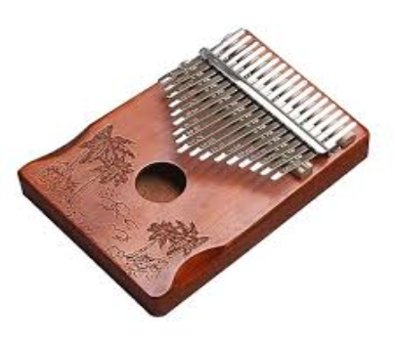

* + - 1. State 4
      2. User Interface

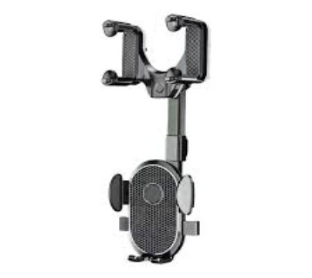

* + - 1. State 5
      2. User Interface



* + - 1. State 6
      2. User Interface



* + - 1. State 7
      2. User Interface

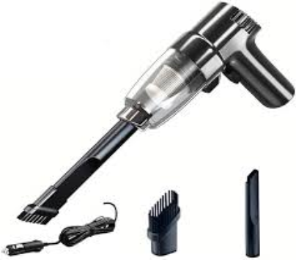

* + - 1. State 8
      2. User Interface

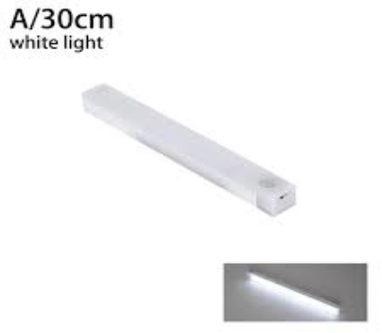

* 1. Categorized Products

Page Loaded:  
 Add Filter ProductCategoryNum contains "[[CategoryNumber]]" to Products

* + 1. User Interface

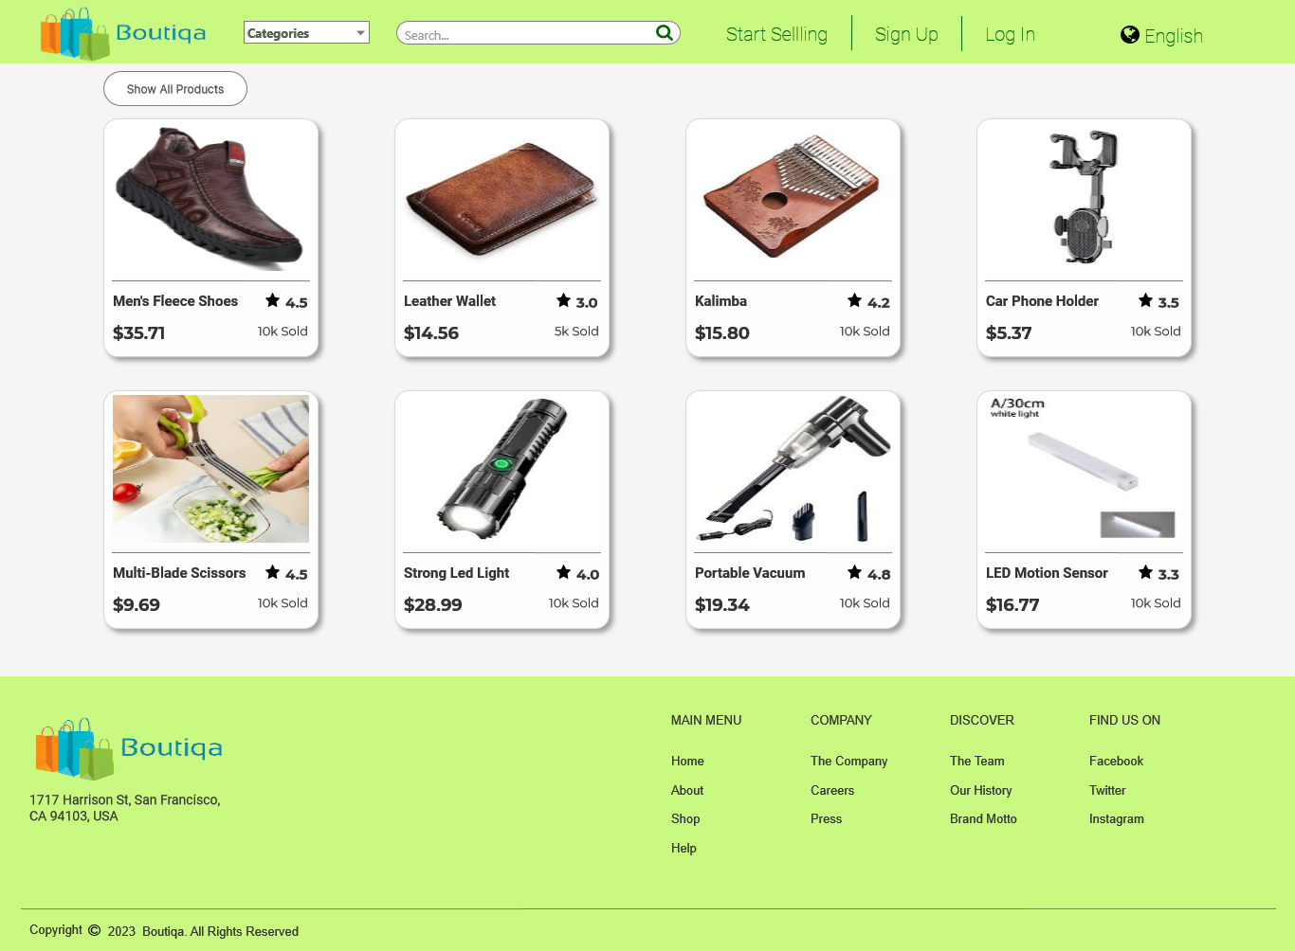

* + 1. Products
       1. User Interface



* 1. Search Results (Landing Page)

Page Loaded:  
 Set text on SearchKeywordPlaceholder equal to value of SearchKeyword  
 Set text on (LandingPageNavBar)/SearchBarInput equal to value of SearchKeyword  
 Add Filter ProductName contains "[[SearchKeyword]]" to Products

* + 1. User Interface

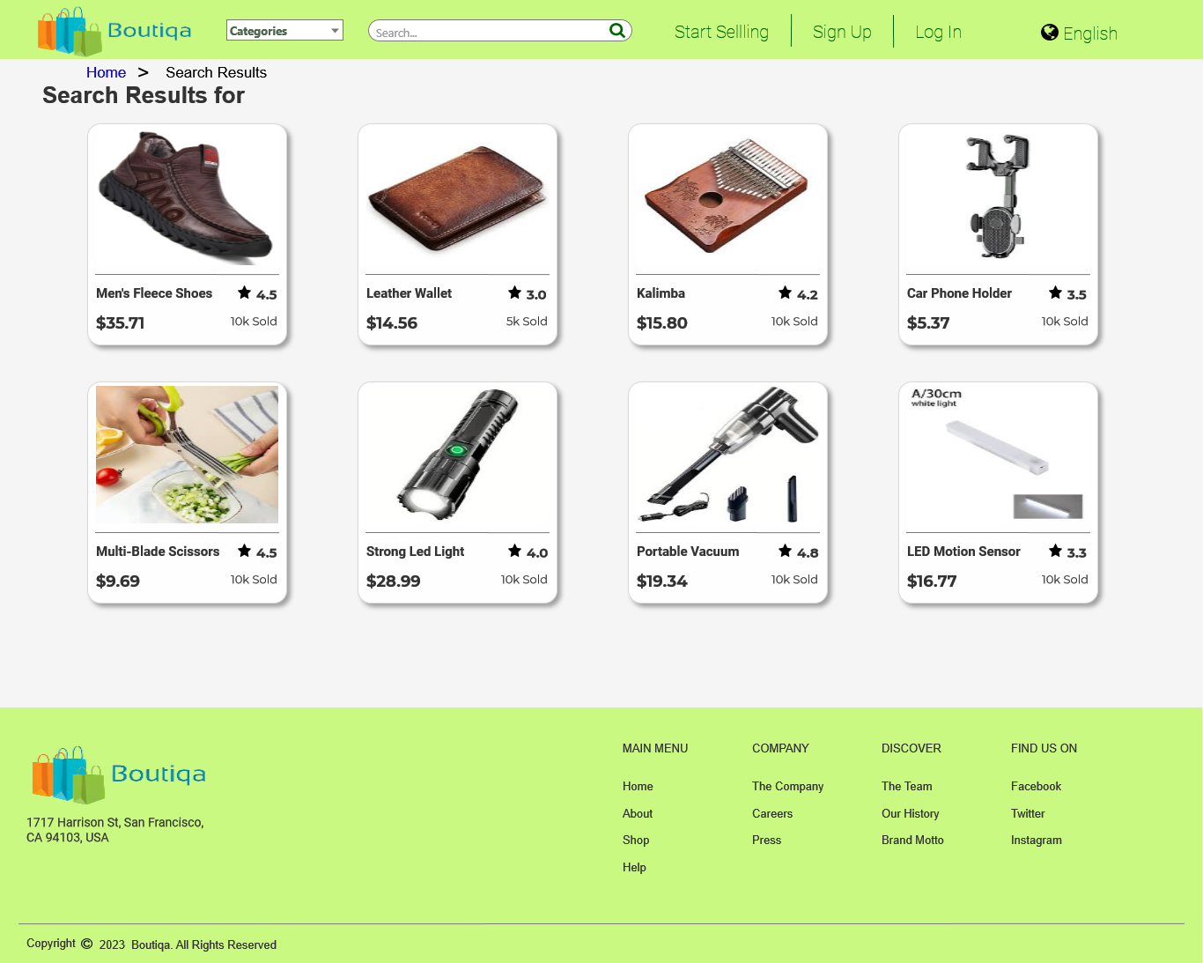

* + 1. Products
       1. User Interface



* 1. Product Details (From Search Results))

Page Loaded:  
 Set text on ProductName equal to value of DetailsProductName  
 Set text on ProductPrice equal to value of DetailsProductPrice  
 Set text on ProductRatings equal to value of DetailsProductRatings  
 Set text on ProductSoldPlaceholder equal to value of DetailsProductSold  
 Set text on ProductDetails equal to value of DetailsProductDescription  
 Set text on ProductNameBreadcrum equal to value of DetailsProductName  
 Set (Dynamic Panel) to to [[DetailsProductImage]]

* + 1. User Interface

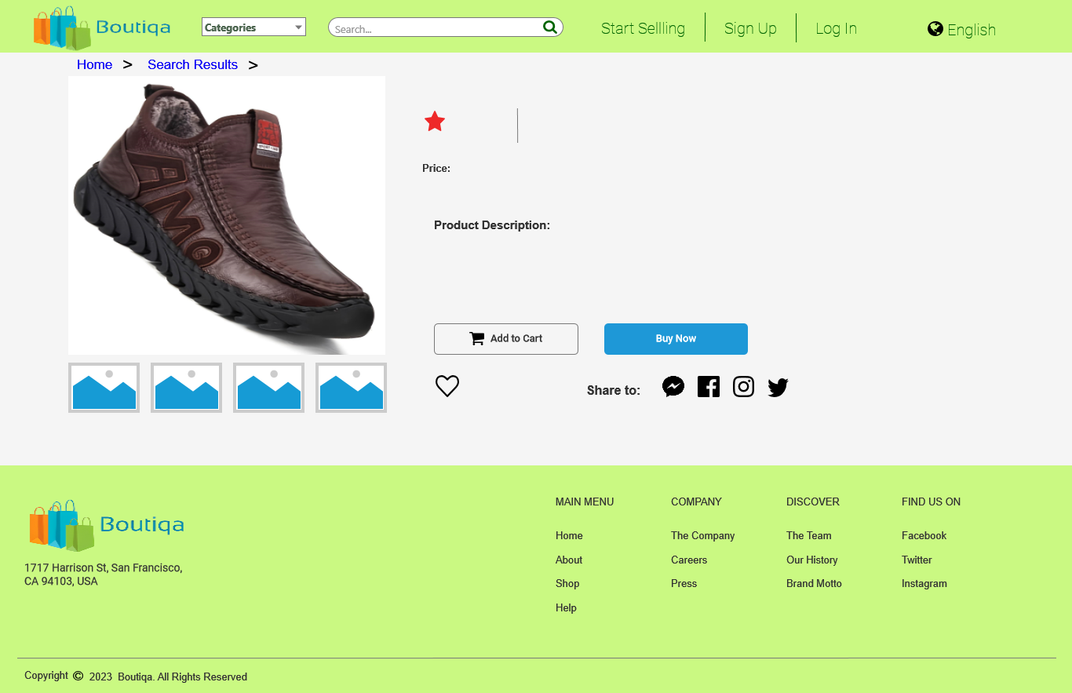

* + 1. Unnamed
       1. State 1
       2. User Interface



* + - 1. State 2
      2. User Interface



* + - 1. State 3
      2. User Interface



* + - 1. State 4
      2. User Interface



* + - 1. State 5
      2. User Interface



* + - 1. State 6
      2. User Interface



* + - 1. State 7
      2. User Interface



* + - 1. State 8
      2. User Interface



* 1. Sign Up (Buyer)
     1. User Interface

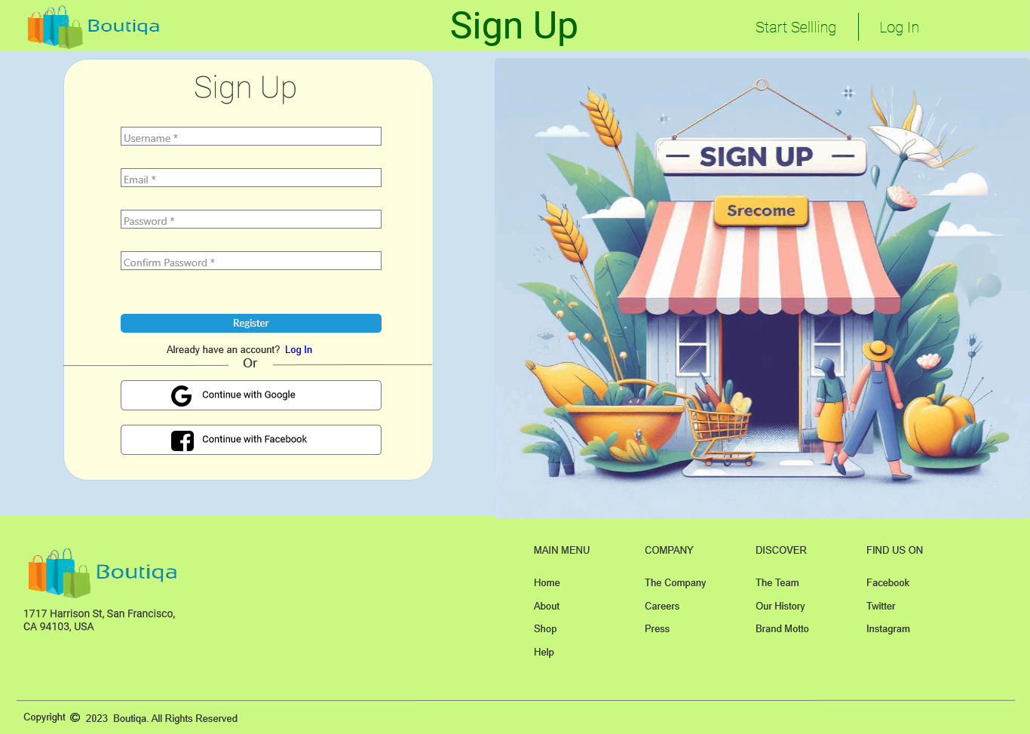

* 1. (Buyer) Sign Up Confirmation Page

Page Loaded:  
 Set text on ConfirmUsername equal to value of Username  
 Set text on ConfirmEmail equal to value of Email

* + 1. User Interface

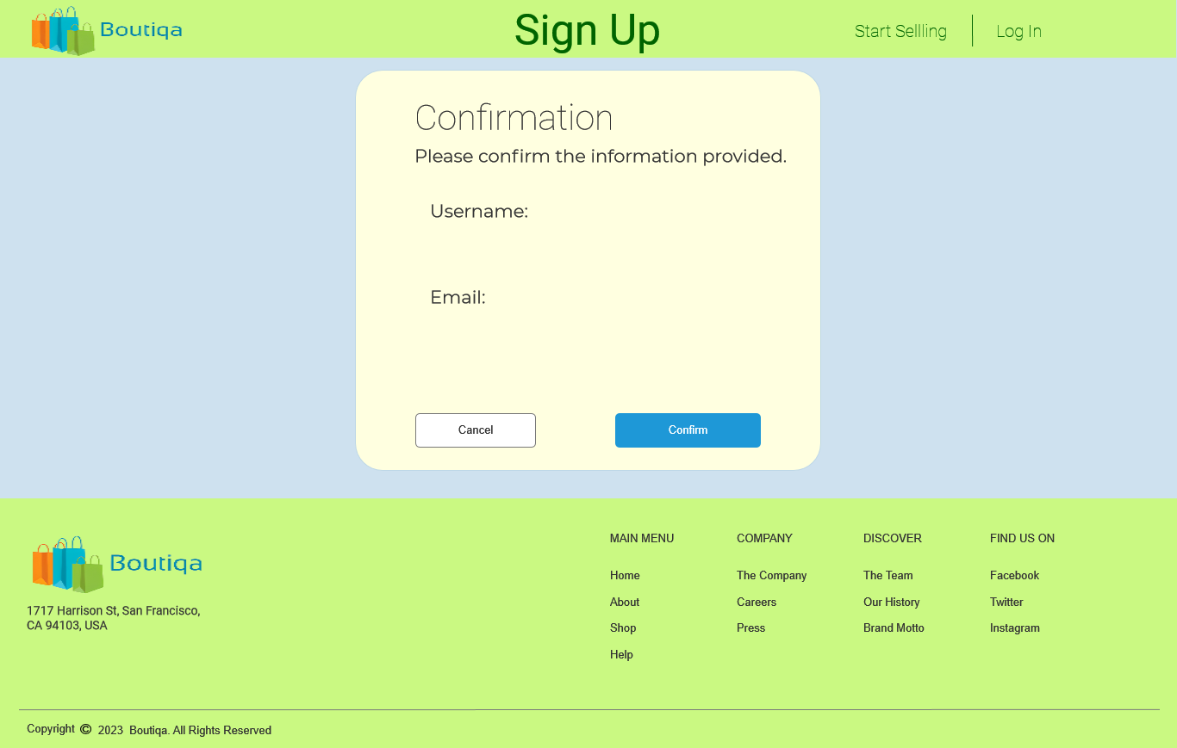

* 1. (Buyer) Successful registration
     1. User Interface

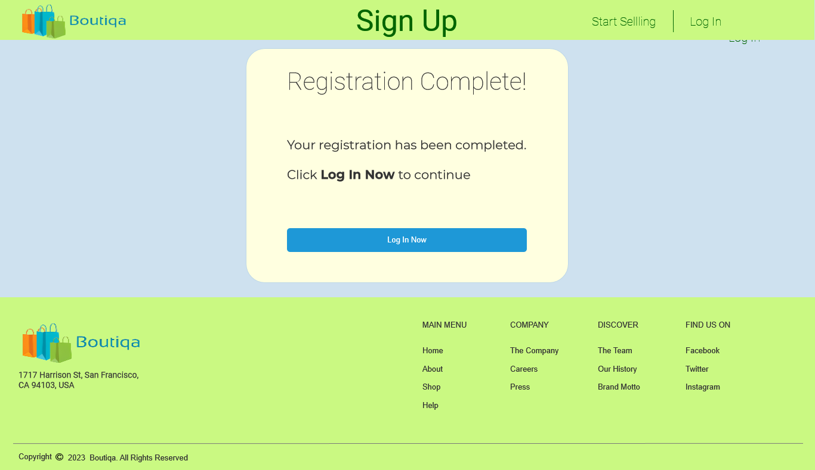

* 1. Sign Up (Seller)
     1. User Interface

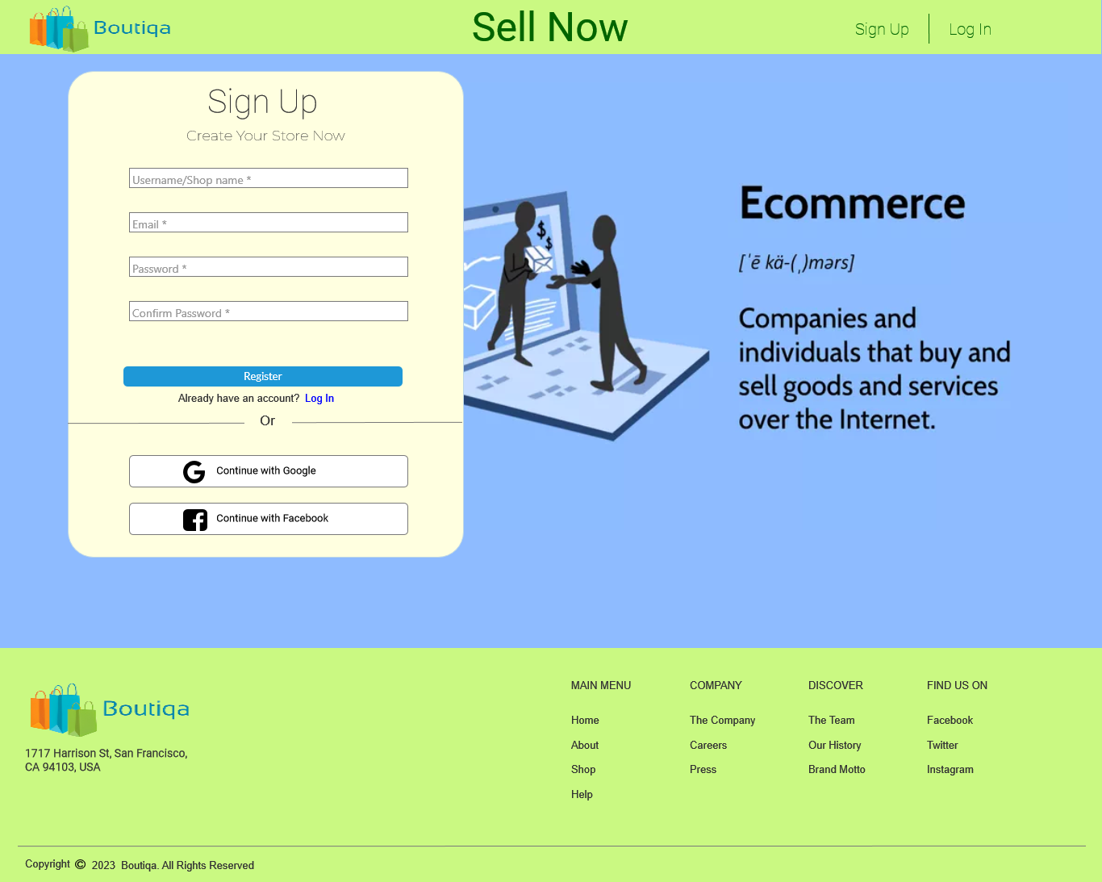

* 1. (Seller) Sign Up Confirmation Page

Page Loaded:  
 Set text on ConfirmUsername equal to value of SellerUserName  
 Set text on ConfirmEmail equal to value of SellerEmail

* + 1. User Interface

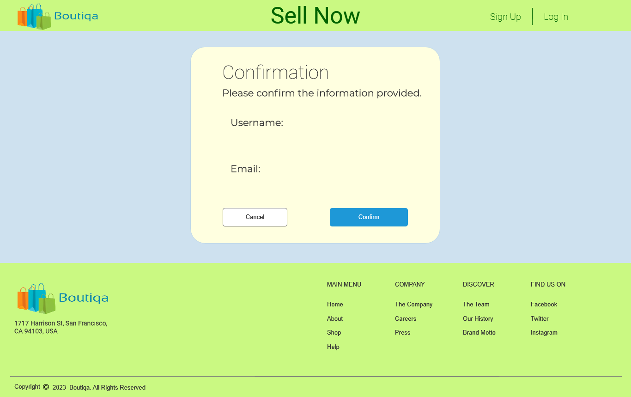

* 1. (Seller) Successful registration
     1. User Interface

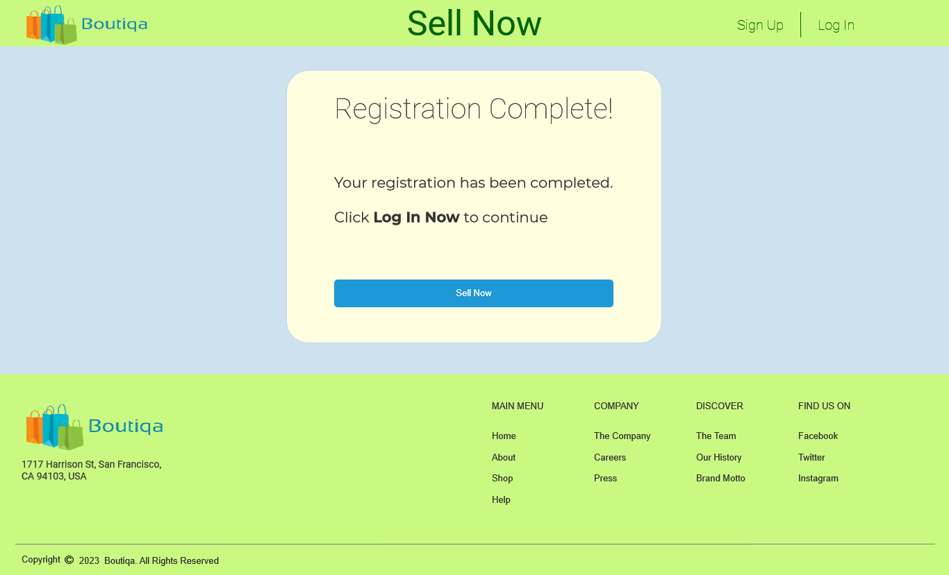

* 1. Log In
     1. User Interface

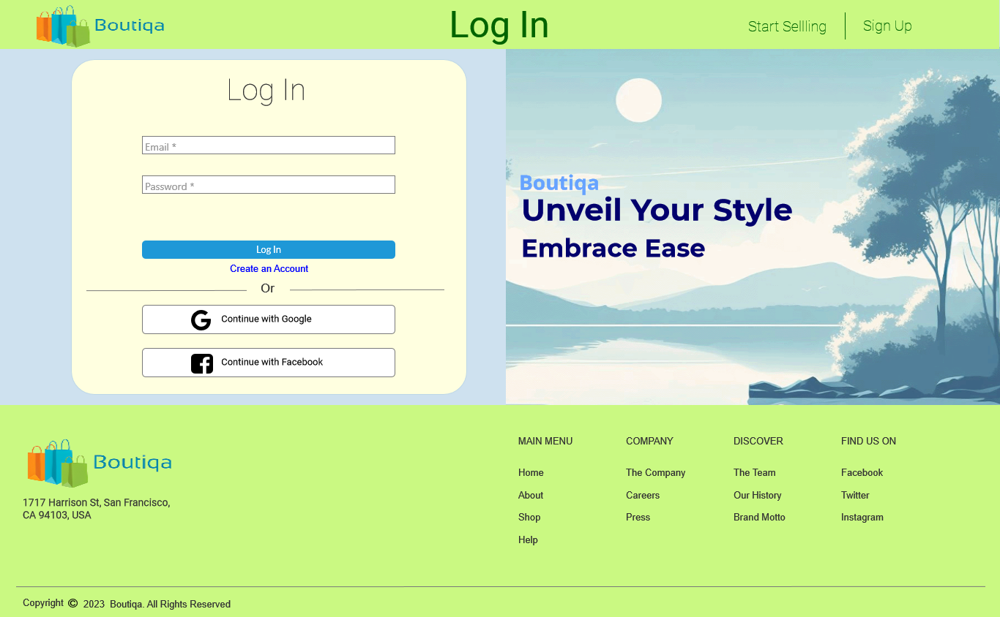

* 1. BuyerHomepage

Page Loaded:  
 Set text on (BuyerNavBar)/UsernamePlacholder equal to value of Username  
 Set text on (BuyerNavBar)/UsernamePlacholder equal to value of Username  
 Set text on (BuyerNavBar)/EmailPlaceholder equal to value of Email

* + 1. User Interface

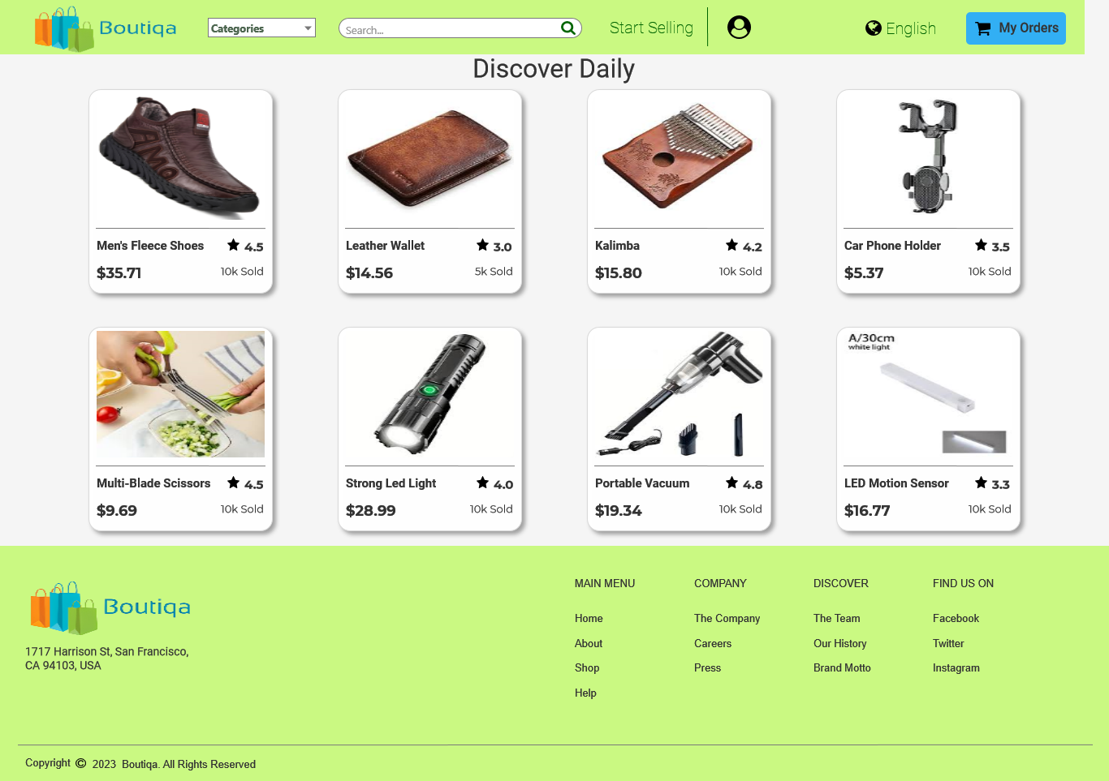

* + 1. Products
       1. User Interface



* 1. Product Details (From Homepage)

Page Loaded:  
 Set text on (BuyerNavBar)/UsernamePlacholder equal to value of Username  
 Set text on (BuyerNavBar)/UsernamePlacholder equal to value of Username  
 Set text on (BuyerNavBar)/EmailPlaceholder equal to value of Email  
 Set text on ProductName equal to value of DetailsProductName  
 Set text on ProductPrice equal to value of DetailsProductPrice  
 Set text on ProductRatings equal to value of DetailsProductRatings  
 Set text on ProductSoldPlaceholder equal to value of DetailsProductSold  
 Set text on ProductDetails equal to value of DetailsProductDescription  
 Set text on ProductNameBreadcrum equal to value of DetailsProductName  
 Set (Dynamic Panel) to to [[DetailsProductImage]]

* + 1. User Interface

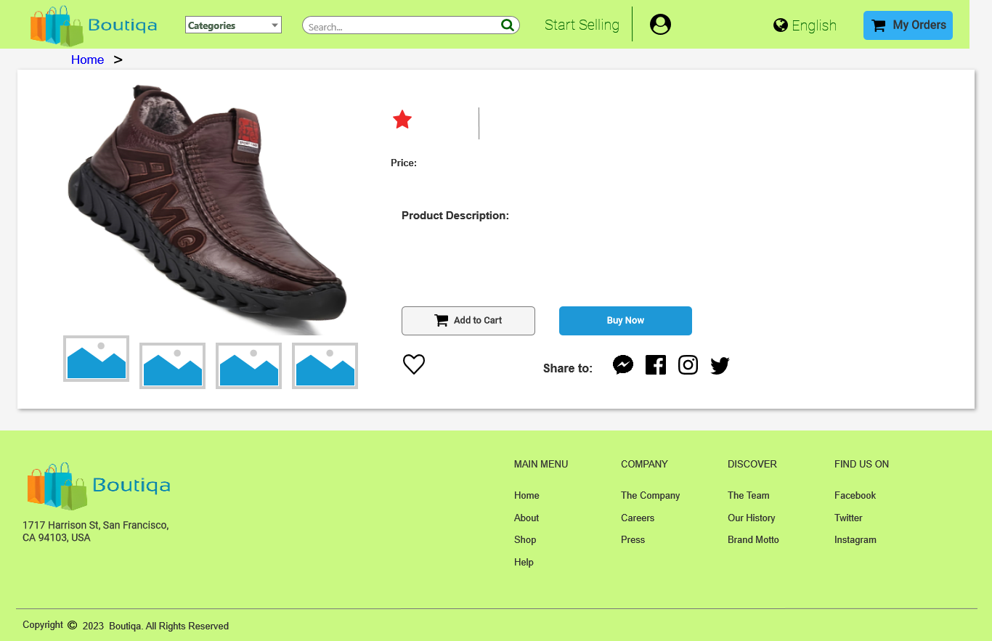

* + 1. Unnamed
       1. State 1
       2. User Interface



* + - 1. State 2
      2. User Interface



* + - 1. State 3
      2. User Interface



* + - 1. State 4
      2. User Interface



* + - 1. State 5
      2. User Interface



* + - 1. State 6
      2. User Interface



* + - 1. State 7
      2. User Interface



* + - 1. State 8
      2. User Interface



* 1. Categorized Products

Page Loaded:  
 Add Filter ProductCategoryNum contains "[[CategoryNumber]]" to Products  
 Set text on (BuyerNavBar)/UsernamePlacholder equal to value of Username  
 Set text on (BuyerNavBar)/UsernamePlacholder equal to value of Username  
 Set text on (BuyerNavBar)/EmailPlaceholder equal to value of Email

* + 1. User Interface

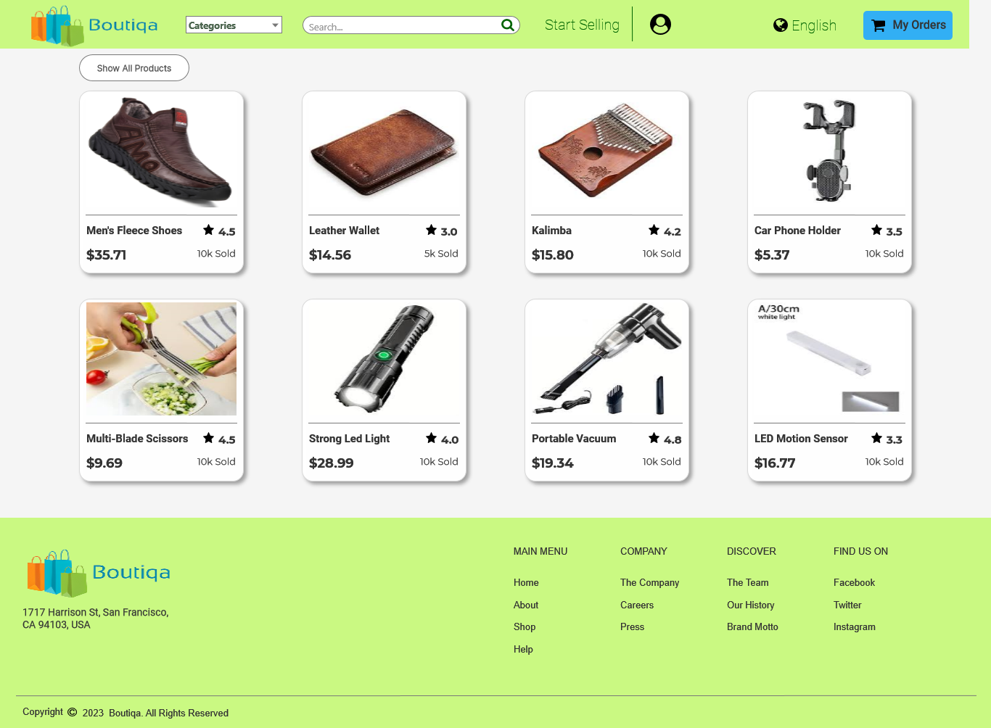

* + 1. Products
       1. User Interface



* 1. Buyer Profile

Page Loaded:  
 Set text on (BuyerNavBar)/UsernamePlacholder equal to value of Username  
 Set text on (BuyerNavBar)/UsernamePlacholder equal to value of Username  
 Set text on (BuyerNavBar)/EmailPlaceholder equal to value of Email  
 Set text on ProfileUsernamePlacholder equal to value of Username  
 Set text on EmailPlaceholder equal to value of Email  
 Set text on Full Name Placeholder equal to value of FullName  
 Set text on Username Placeholder equal to value of Username  
 Set text on Email Placeholder equal to value of Email  
 Set text on Password Placeholder equal to value of Password  
 Set text on Mobile Number Placeholder equal to value of MobileNumber  
 Disable Full Name Placeholder  
 Disable Username Placeholder  
 Disable Email Placeholder  
 Disable Password Placeholder  
 Disable Mobile Number Placeholder

* + 1. User Interface

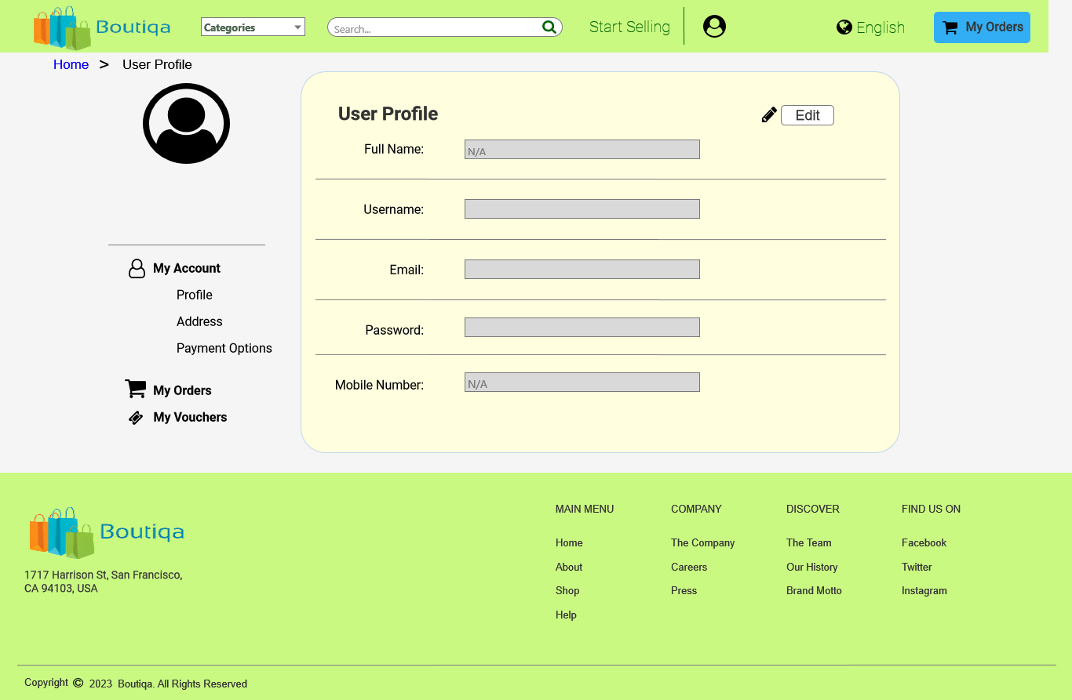

* 1. Search Results

Page Loaded:  
 Set text on (BuyerNavBar)/UsernamePlacholder equal to value of Username  
 Set text on (BuyerNavBar)/UsernamePlacholder equal to value of Username  
 Set text on (BuyerNavBar)/EmailPlaceholder equal to value of Email  
 Set text on SearchKeywordPlaceholder equal to value of SearchKeyword  
 Set text on (BuyerNavBar)/SearchBarInput equal to value of SearchKeyword  
 Add Filter ProductName contains text on (BuyerNavBar)/SearchBarInput to Products

* + 1. User Interface

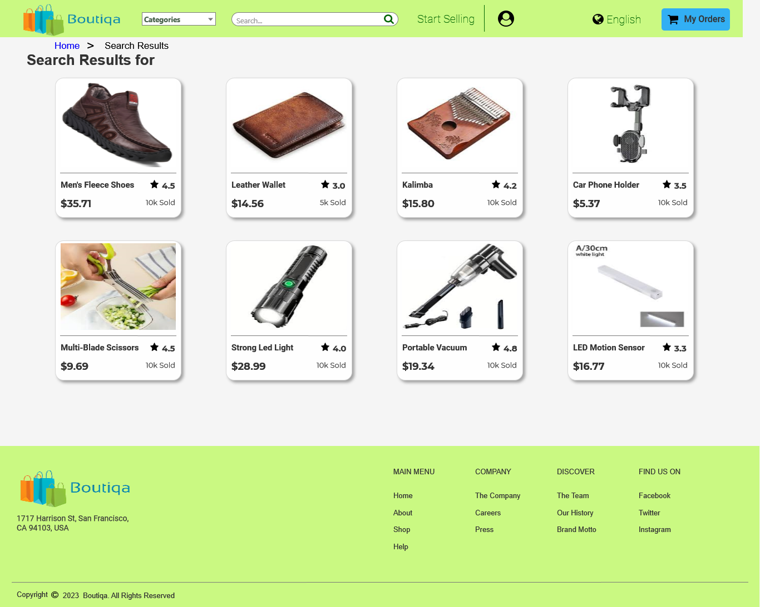

* + 1. Products
       1. User Interface



* 1. Product Details (From Search Results))

Page Loaded:  
 Set text on (BuyerNavBar)/UsernamePlacholder equal to value of Username  
 Set text on (BuyerNavBar)/UsernamePlacholder equal to value of Username  
 Set text on (BuyerNavBar)/EmailPlaceholder equal to value of Email  
 Set text on ProductName equal to value of DetailsProductName  
 Set text on ProductPrice equal to value of DetailsProductPrice  
 Set text on ProductRatings equal to value of DetailsProductRatings  
 Set text on ProductSoldPlaceholder equal to value of DetailsProductSold  
 Set text on ProductDetails equal to value of DetailsProductDescription  
 Set text on ProductNameBreadcrum equal to value of DetailsProductName  
 Set (Dynamic Panel) to to [[DetailsProductImage]]

* + 1. User Interface

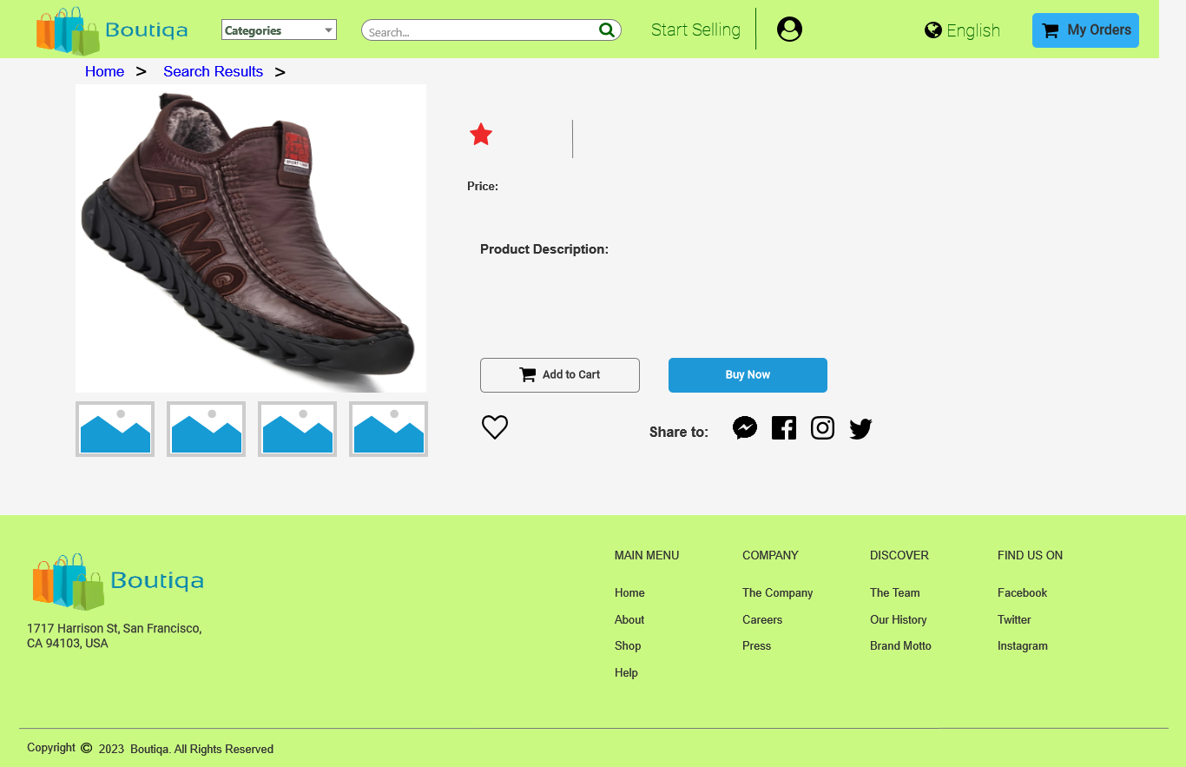

* + 1. Unnamed
       1. State 1
       2. User Interface



* + - 1. State 2
      2. User Interface



* + - 1. State 3
      2. User Interface



* + - 1. State 4
      2. User Interface



* + - 1. State 5
      2. User Interface



* + - 1. State 6
      2. User Interface



* + - 1. State 7
      2. User Interface



* + - 1. State 8
      2. User Interface



* 1. SellerHomepage
     1. User Interface

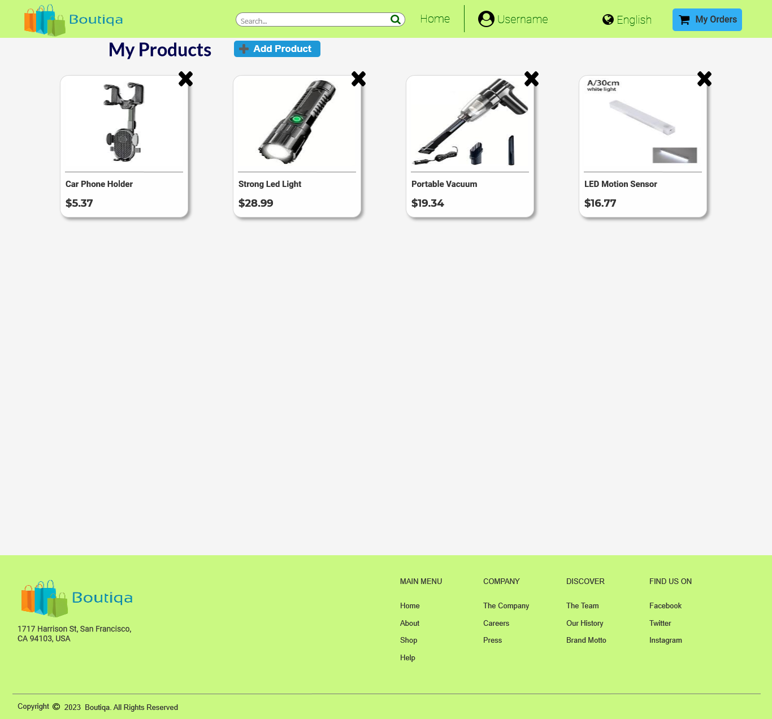

* + 1. Products
       1. User Interface

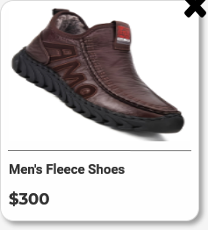

* 1. Product Details (From Homepage) (1)

Page Loaded:  
 Set text on (SellerNavBar)/UsernamePlacholder equal to value of SellerUserName  
 Set text on (SellerNavBar)/UsernamePlacholder equal to value of SellerUserName  
 Set text on (SellerNavBar)/EmailPlaceholder equal to value of SellerEmail  
 Set text on ProductName equal to value of DetailsProductName  
 Set text on ProductPrice equal to value of DetailsProductPrice  
 Set text on ProductDetails equal to value of DetailsProductDescription  
 Set text on ProductNameBreadcrum equal to value of DetailsProductName  
 Set (Dynamic Panel) to to [[DetailsProductImage]]

* + 1. User Interface

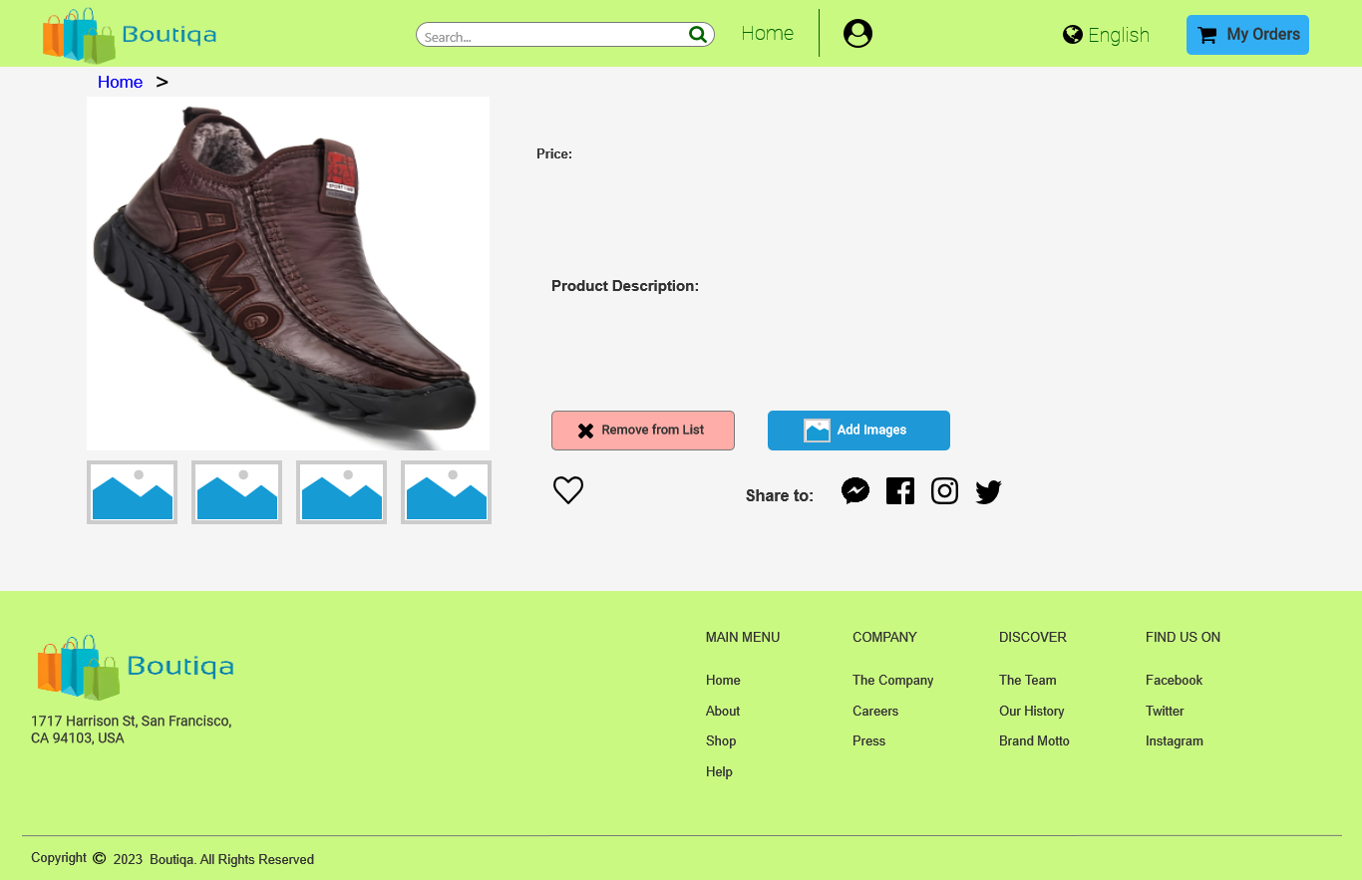

* + 1. Unnamed
       1. State 1
       2. User Interface



* + - 1. State 2
      2. User Interface



* + - 1. State 3
      2. User Interface



* + - 1. State 4
      2. User Interface



* + - 1. State 5
      2. User Interface



* + - 1. State 6
      2. User Interface



* + - 1. State 7
      2. User Interface



* + - 1. State 8
      2. User Interface



* 1. Seller Profile

Page Loaded:  
 Set text on (SellerNavBar)/UsernamePlacholder equal to value of SellerUserName  
 Set text on (SellerNavBar)/UsernamePlacholder equal to value of SellerUserName  
 Set text on (SellerNavBar)/EmailPlaceholder equal to value of SellerEmail  
 Set text on ProfileUsernamePlacholder equal to value of SellerUserName  
 Set text on EmailPlaceholder equal to value of SellerEmail  
 Set text on Shop Name Placeholder equal to value of SellerShopName  
 Set text on Username Placeholder equal to value of SellerUserName  
 Set text on Email Placeholder equal to value of SellerEmail  
 Set text on Password Placeholder equal to value of SellerPassword  
 Set text on Mobile Number Placeholder equal to value of SellerMobileNumber  
 Disable Shop Name Placeholder  
 Disable Username Placeholder  
 Disable Email Placeholder  
 Disable Password Placeholder  
 Disable Mobile Number Placeholder

* + 1. User Interface

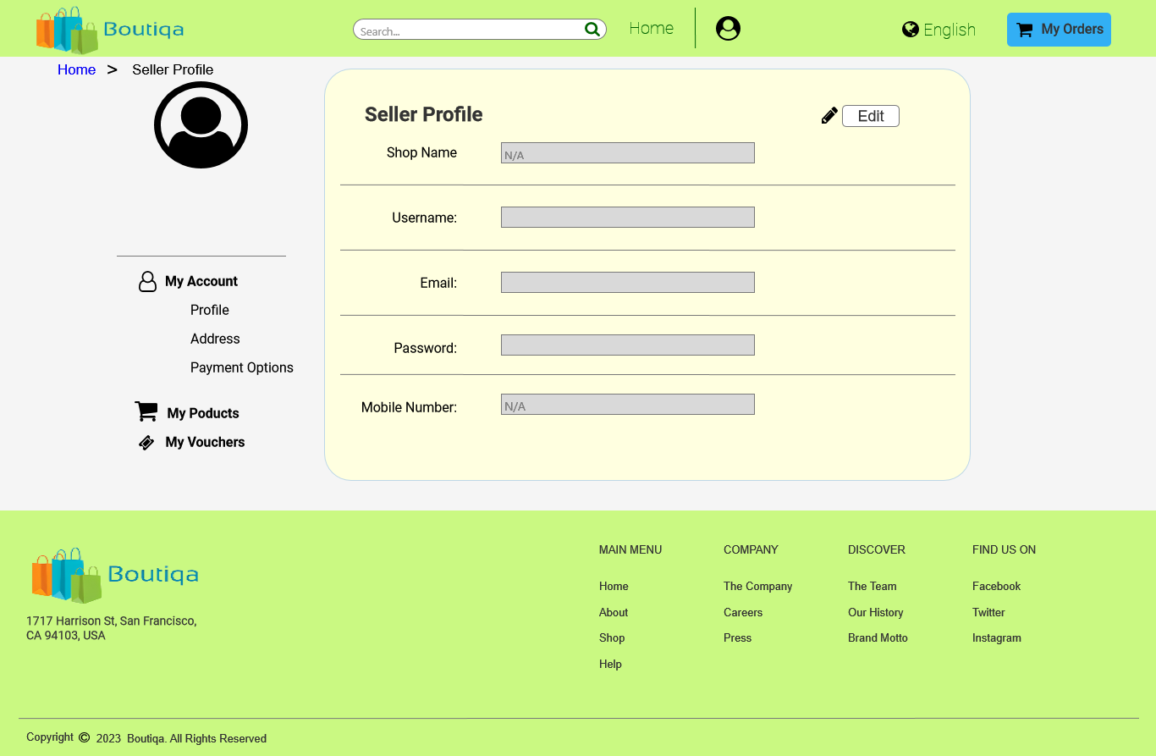

1. Components
   1. Component List

LandingPageNavBar  
BuyerNavBar  
SellerNavBar  
CategoriesNavBar  
Common Footer

* 1. LandingPageNavBar
     1. User Interface



* 1. BuyerNavBar

Page Loaded:  
 Set text on UsernamePlacholder equal to value of Username  
 Set text on UsernamePlacholder equal to value of Username  
 Set text on EmailPlaceholder equal to value of Email

* + 1. User Interface



* 1. SellerNavBar

Page Loaded:  
 Set text on UsernamePlacholder equal to value of SellerUserName  
 Set text on UsernamePlacholder equal to value of SellerUserName  
 Set text on EmailPlaceholder equal to value of SellerEmail

* + 1. User Interface

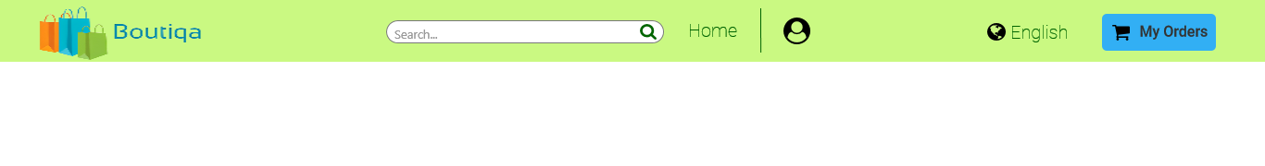

* 1. CategoriesNavBar

Page Loaded:  
 Enable/Disable Widget

* + 1. User Interface



* 1. Common Footer
     1. User Interface

